Step-by-step directions
- Grab ghost or pumpkin template.
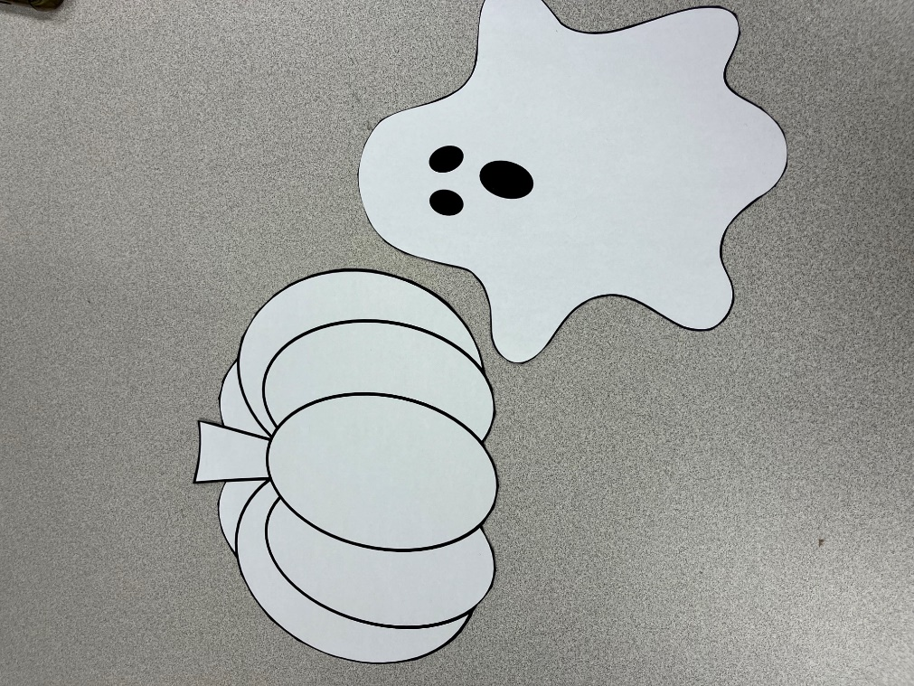
- Tear small pieces of tissue paper/construction paper of the color of your choosing
  - If child prefers, crayons can also be used to decorate template.
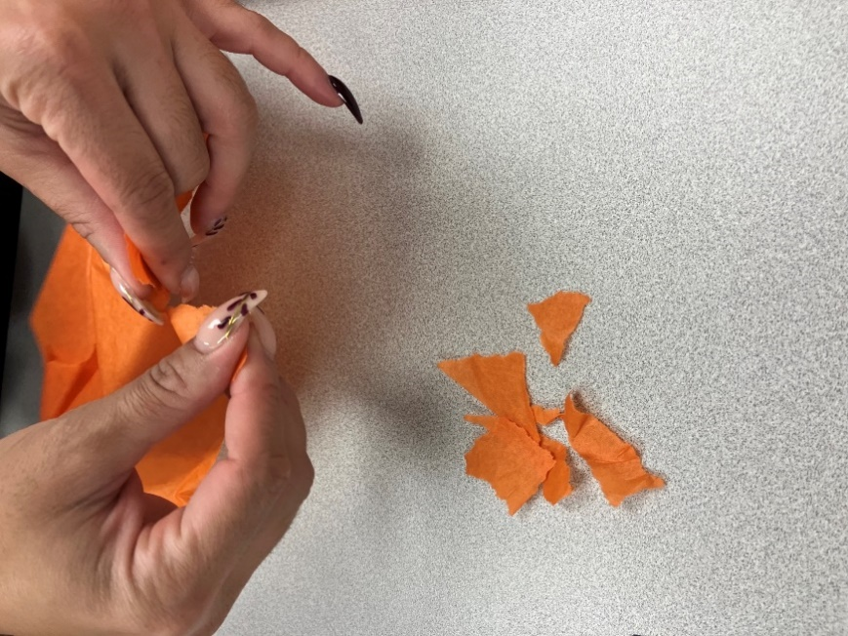

- Glue the colored pieces onto your template.
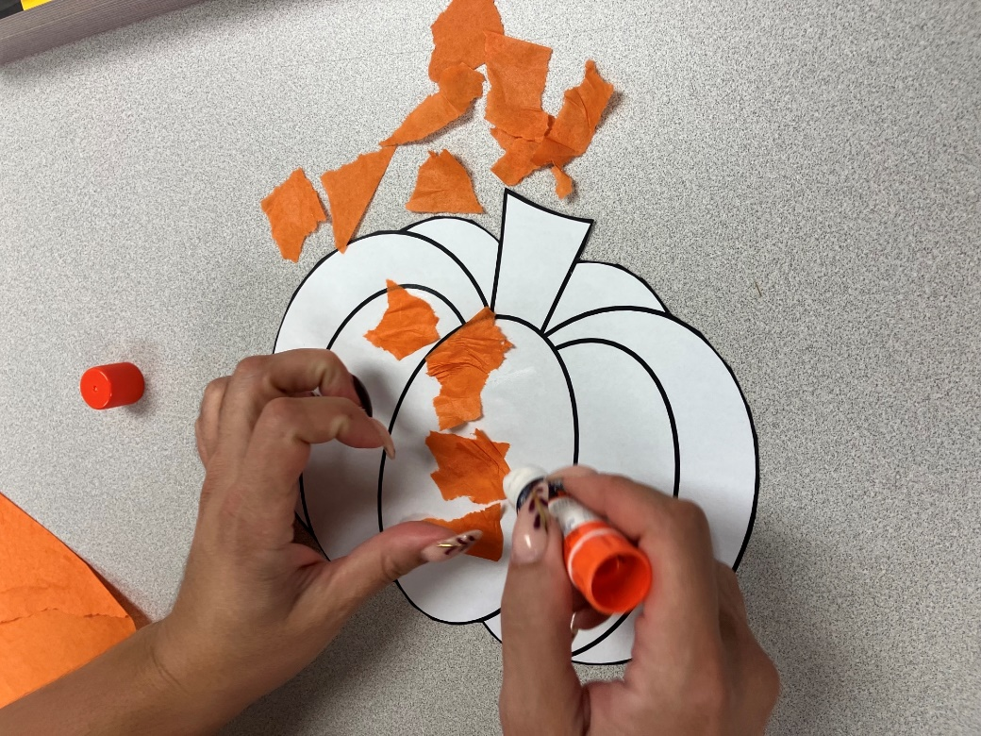

- Have fun! 😊
