Perinatal Loss Support Groups

Name/Location | Contact
For Fathers Only (virtual)  Unite, Inc. | UNITE Voice Mail: 484-758-0002  Email: boardchair@unitegriefsupport.org  Registration is required.  Register at  
Postpartum Support International | Must register for a free account in order to participate. A subscription option will appear but subscription is not necessary. Scroll past the first set of groups to see the Grief and Loss options.  
Griffin Cares Foundation  Virtual groups | 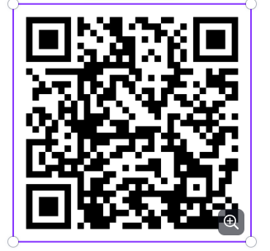
SHARE  (National) Support Group | 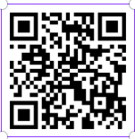
SHARE Support Group  Saint Peter’s University Hospital  3rd Thursday of the month | Irina Mariano-Brown, MSW, LCSW  Social Worker  Social Work Department  Registration is required.  imariano@saintpetersuh.com or  732-745-8522
SHARE Support Group  Riverview Medical Center  Blaisdell Pavilion, Mausner Room, 5th Floor  1 Riverview Plaza  Red Bank, NJ | Diane Labarbera  732-530-2315  Share.rmc@gmail.com
Stephy’s Place  The Swede Chevalier Building  210 West Front Street, Suite 209  Red Bank, NJ 07701 | 732-797-9739  Stephysplace15@gmail.com  
Support Together and Reflect  (STAR)  3rd Monday of the month  Capital Health Primary Care-Hamilton  1445 Whitehorse-Mercerville Road  Suite 103  Hamilton, NJ | Registration is required.  Register at  
Star Legacy Foundation | 
Tears Loss Support Group  Moorestown Library  111 W. 2nd Street  Moorestown, NJ | Dara  609-458-7487
UNITE Perinatal Loss Bereavement Group  (sponsored by Penn Medicine Princeton Health)  1st Wednesday of the month | Bernadette Flynn-Kelton, BSN, RN, PCE, IBCLC, RLC  Registration is required.  Register at    (keyword: Virtual Support Groups)

30 Silverline Drive
Suite 1, 2nd Floor
North Brunswick, NJ 08902
perinatallosssupport@cjfhc.org

