

**Popsicle Stick Summer Craft**

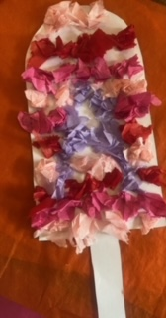

**For this craft, you will need the following supplies:**

Popsicle template

Colored tissue paper

Child-friendly scissors

Glue stick

Crayons

Popsicle stick

**Instructions:**

**Step 1:**

Cut out the popsicle stick from the template.

**Step 2:**

Tear the tissue paper into small pieces. These pieces will be glued onto the popsicle.

**Step 3:**

Glue the pieces of tissue paper onto the popsicle template. Depending on the age of the child and their interest, you can simply scatter the pieces around the template, arrange them in a pattern, a letter, shape or any other creative idea.

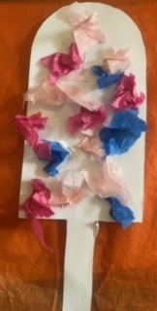  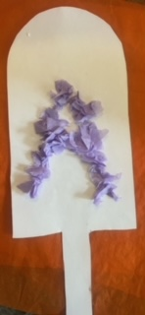

**Step 4:**

Color the popsicle stick.

**Step 5:**

Glue the popsicle stick onto the back of the template.

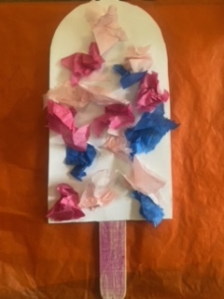 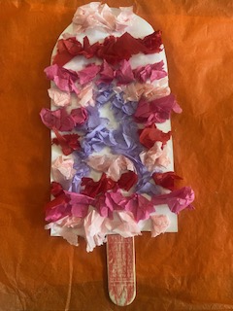

**Step 6:**

Bring the popsicle to life:

* What would you name this popsicle?
* What is your favorite popsicle flavor?
* Are popsicles cold or hot?
* Imagine you are on a beach or in the park eating a popsicle.

For more fun, free activities that you can do with your child, contact Central Jersey Family Health Consortium’s Early Childhood Specialist Team today at [infoci@cjfhc.org](mailto:infoci@cjfhc.org).

**www.cjfhc.org**