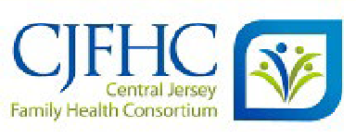

NJ Postpartum Resources and Support Network (NJPRSN) Brochure Order Form

June 2025

|  |  |  |  |  |
| --- | --- | --- | --- | --- |
| Requestor:  Kelly Lamonica | | | | Order Date:  8/17/2025 |
| Phone #:  609-853-7676 | Email Address:  kelly.lamonica@PennMedicine.Upenn.edu | | | |
| Recipient’s Name: | | | | |
| Kelly Lamonica | | | | |
| Department:  Mother-Baby Unit | | | | |
| Organization:  enn Medicine Princeton | | | | |
| Street Address:  1 Plainsboro Rd | | | | |
| City:  Plainsboro | | State:  NJ | Zip:  08536 | |

|  |  |  |  |  |  |  |  |  |  |
| --- | --- | --- | --- | --- | --- | --- | --- | --- | --- |
| **All items are shipped free of charge** | | **Quantity** | | | | | | | |
| A. | *New Baby=New Emotions, The Baby Blues and Signs of Something More Serious,*  **English** | 100 |  | 250 |  | 500 | X | 1000 |  |
| B. | *New Baby=New Emotions, The Baby Blues and Signs of Something More Serious***, Spanish** | 100 |  | 200 | X | 500 |  | 1000 |  |

Email order form to: [NJPRSN@CJFHC.org](mailto:PPW@CJFHC.org)

Mail order form to: CJFHC, 30 Silverline Dr., 2nd floor, Suite 1, North Brunswick, NJ 08902

**Contact Kathy Donaldson at** [**NJPRSN@CJFHC.org**](mailto:NJPRSN@CJFHC.org) **with any questions**